Test Case: tc001_SPX_Dev5_Crear_Requisicion_Spot_Tipo_Cobro_CC
Step 1 - Enter username and password and click to button Enter : Credentials Entered
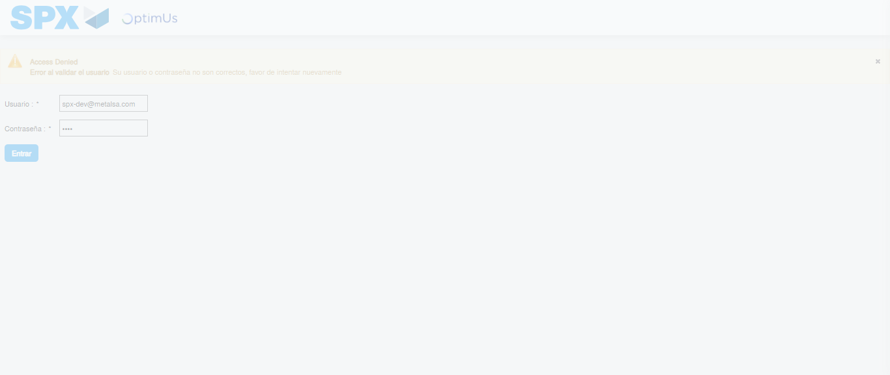Image file-name: QC_Testing-tc001_SPX_Dev5_Crear_Requisicion_Spot_Tipo_Cobro_CC-1783979057034

Step 2 - Select to UEN and Access to Spot Buy Requisitions : UEN Correctly selected and Correct access
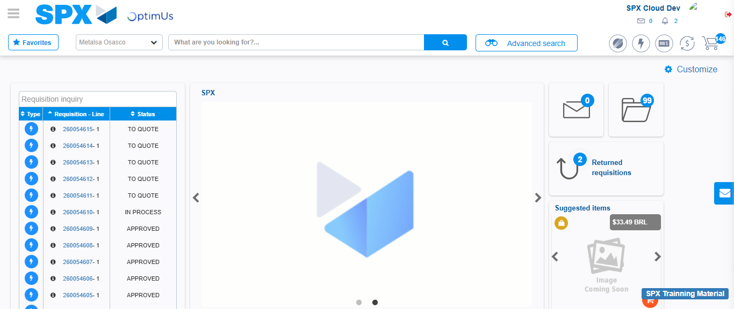Image file-name: QC_Testing-tc001_SPX_Dev5_Crear_Requisicion_Spot_Tipo_Cobro_CC-1783979104827

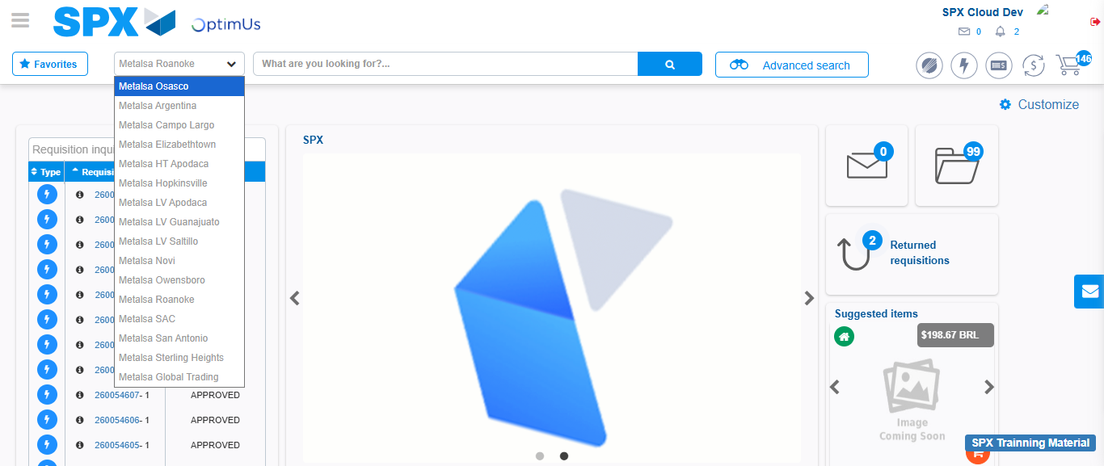Image file-name: QC_Testing-tc001_SPX_Dev5_Crear_Requisicion_Spot_Tipo_Cobro_CC-1783979107796

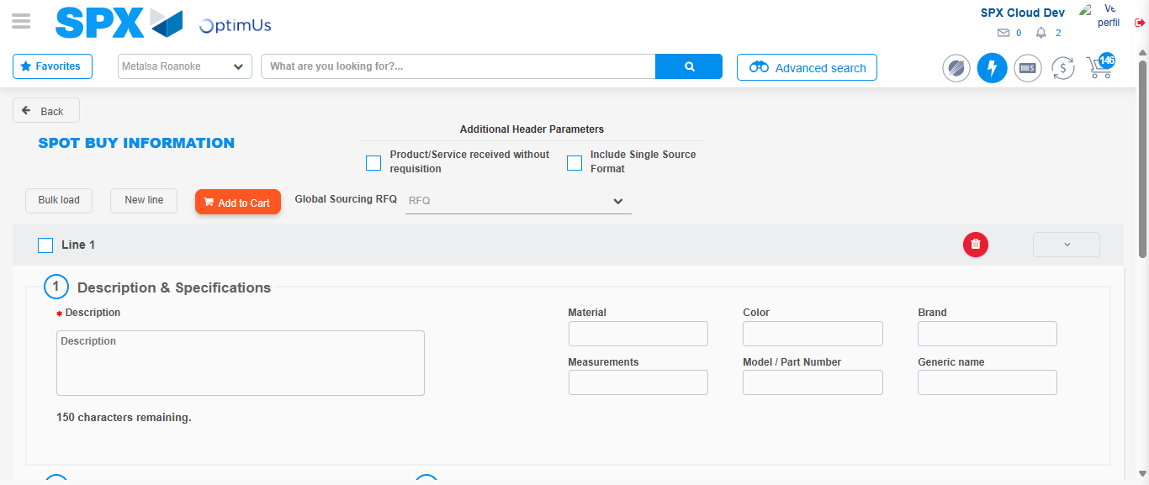Image file-name: QC_Testing-tc001_SPX_Dev5_Crear_Requisicion_Spot_Tipo_Cobro_CC-1783979116826

Step 3 - Data Capture Spot Buy Requisition : Data captured correctly
Image file-name: QC_Testing-tc001_SPX_Dev5_Crear_Requisicion_Spot_Tipo_Cobro_CC-1783979117123

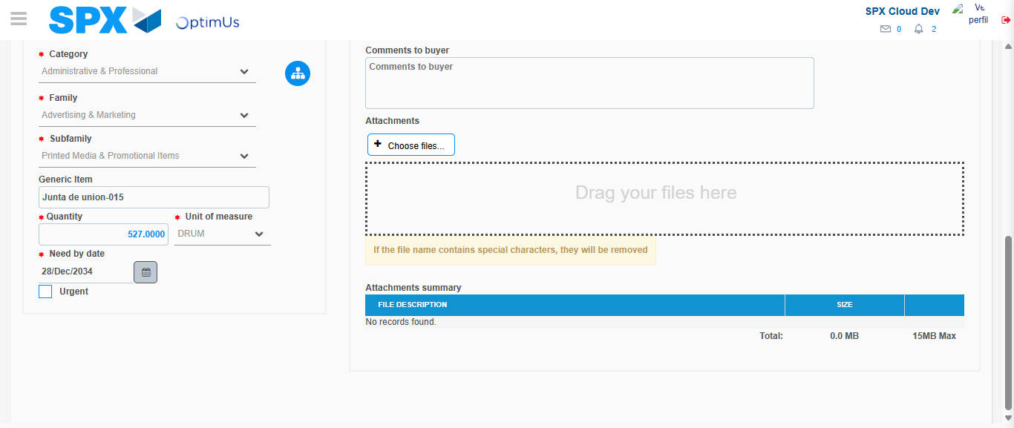Image file-name: QC_Testing-tc001_SPX_Dev5_Crear_Requisicion_Spot_Tipo_Cobro_CC-1783979128839

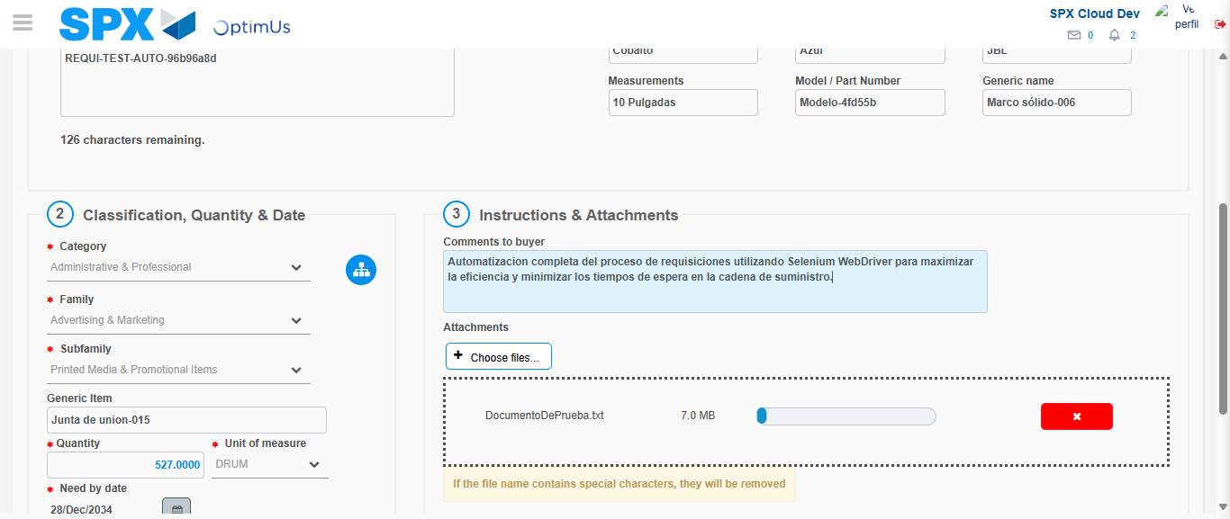Image file-name: QC_Testing-tc001_SPX_Dev5_Crear_Requisicion_Spot_Tipo_Cobro_CC-1783979129854

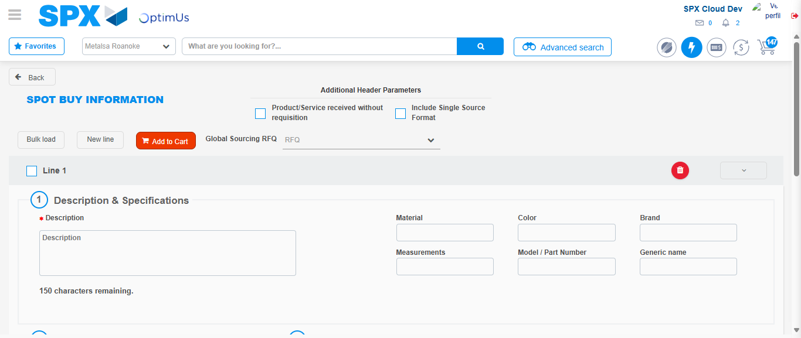Image file-name: QC_Testing-tc001_SPX_Dev5_Crear_Requisicion_Spot_Tipo_Cobro_CC-1783979140255

Step 7 - Return to Main Page SPX : Return to Main Page SPX
Image file-name: QC_Testing-tc001_SPX_Dev5_Crear_Requisicion_Spot_Tipo_Cobro_CC-1783979104827

Image file-name: QC_Testing-tc001_SPX_Dev5_Crear_Requisicion_Spot_Tipo_Cobro_CC-1783979107796

Image file-name: QC_Testing-tc001_SPX_Dev5_Crear_Requisicion_Spot_Tipo_Cobro_CC-1783979116826

Image file-name: QC_Testing-tc001_SPX_Dev5_Crear_Requisicion_Spot_Tipo_Cobro_CC-1783979142534

Image file-name: QC_Testing-tc001_SPX_Dev5_Crear_Requisicion_Spot_Tipo_Cobro_CC-1783979142704

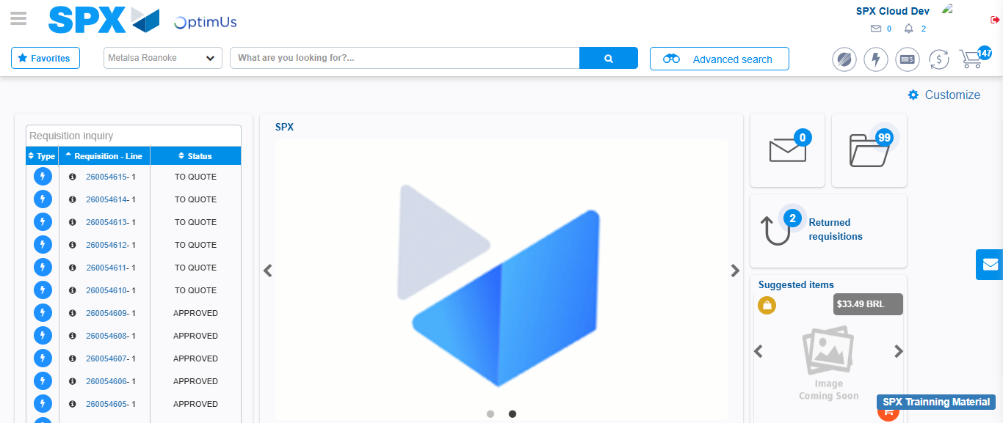Image file-name: QC_Testing-tc001_SPX_Dev5_Crear_Requisicion_Spot_Tipo_Cobro_CC-1783979163983

Step 8 - Log Out : Log Out SPX
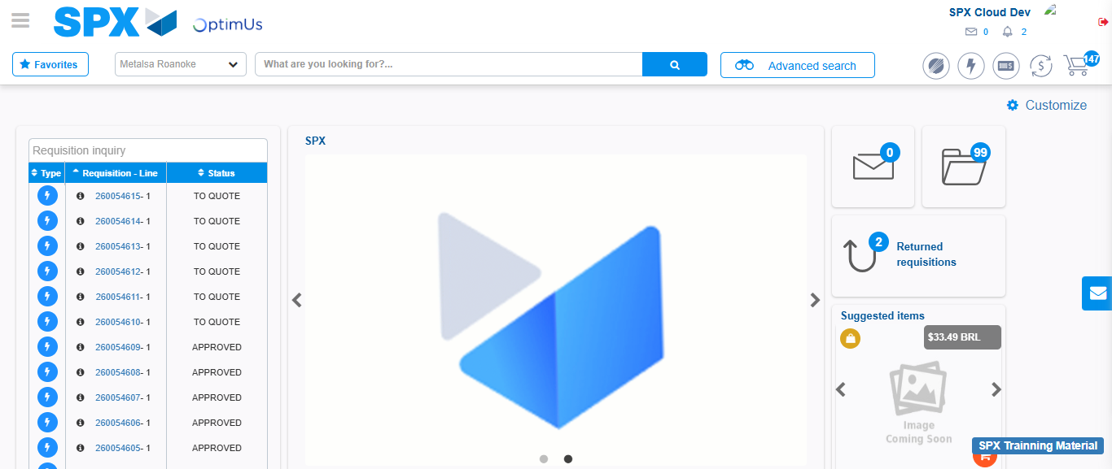Image file-name: QC_Testing-tc001_SPX_Dev5_Crear_Requisicion_Spot_Tipo_Cobro_CC-1783979164320

